CSA1413
COMPILER DESIGN
Name: K.SANJAY
Reg No: 192511367
Find the HTML tags

Aim:
To write a LEX program to identify and print all HTML tags present in the given HTML file.

Algorithm:
- Start the program.
- Include the required header file.
- Define a regular expression to match HTML opening and closing tags.
- Open the given HTML file and check for errors.
- Display the heading “HTML Tags”.
- Scan the file using yylex() and print each matched HTML tag.
- Ignore all other characters in the file.
- Close the file and terminate the program.

Pseudocode:
BEGIN
Include stdio.h
Define regular expression to match HTML tags
IF input file is provided THEN
Open the file
IF file opening fails THEN
Print error message
EXIT
END IF
END IF
Print "HTML Tags:"
CALL yylex()
IF input file was provided THEN
Close the file
END IF
END

Code:
%{
#include <stdio.h>
%}
%%
\<\/?[A-Za-z][A-Za-z0-9]*[^<>]*\> {
printf("HTML Tag: %s\n", yytext);
}
.|\n ;
%%
int main(int argc, char *argv[])
{
if (argc > 1)
{
yyin = fopen(argv[1], "r");
if (yyin == NULL)
{
printf("Cannot open input file!\n");
return 1;
}
}
printf("HTML Tags:\n");
yylex();
if (argc > 1)
fclose(yyin);
return 0;
}
int yywrap(void)
{
return 1;
}

Input:
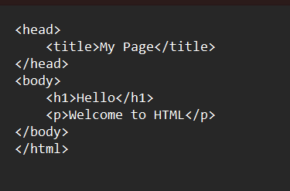

Output:
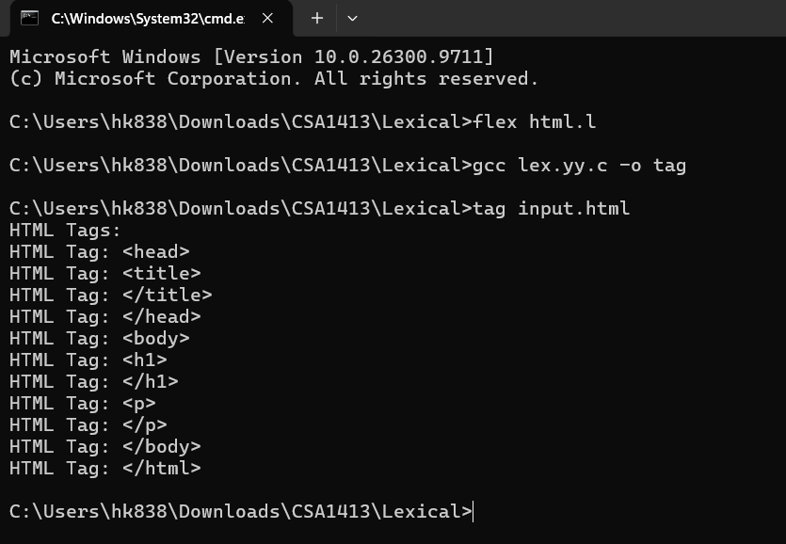

Result:
Thus, the LEX program to identify and print all HTML tags present in the given HTML file was executed successfully.

